Project: Housing Management System for AIUBians
Group Members:
1.Mahfuza Sharmili Jui (19-39398-1)
2.Nahian Sajjad (19-41154-2)
3.Sreejan Roy (19-39737-1)

Entity:
1. Student
S_id, S_name, S_email, S_phone, Aiub_ID
2. Flat Owner
F_id, F_name, F_email, F_phone, F_NID
3. Admin
A_id, A_name, A_email
4. Flat
H_id, H_address, H_price, H_status, H_APT number
Final Table:
Admin: A_id, A_name, A_email
Flat Owner: F_id, F_name, F_email, F_phone, F_NID
Student: S_id, S_name, S_email, S_phone, Aiub_ID
H_ID
Flat: H_id, H_name, H_address, H_price, H_status, H_APT number
F_ID
Flat owner_Admin: A_id, F_ID
Student_Admin: A_ID, S_ID
ER DIAGRAM:

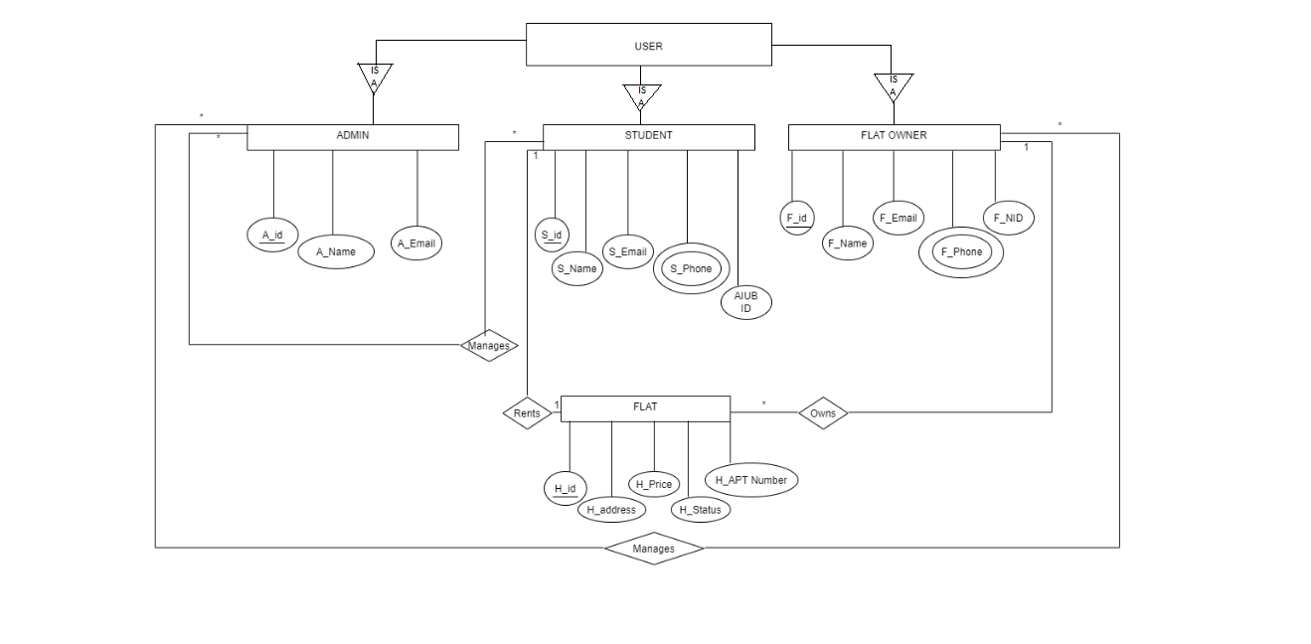

Forms:
1. User registration form
2. User login form
3.Update user info
4. Add house (Flat owner adds a house)
5. Admin after login form (Delete and search user)
6.Rent house
7.Payment
8.Leave house
9.Help
Static Pages:
1.Admin Homepage
2.Student Homepage
3. House owner Homepage

